Chaddleworth St. Andrew’s and Shefford
Church of England Federated Primary Schools
‘Living life in all its fullness’

Child Protection - Safeguarding Policy and Procedure

This policy was adopted by the Governing Body on 10th September, 2025
This policy is due for review on September 2026

As a federation of two Church schools we are at the heart of the community and strive to ‘live life in all its fullness’, in partnership with parents and the wider community.
Chaddleworth St. Andrew’s and Shefford CE Primary Schools are committed to enabling all pupils to achieve their full potential. We will do this through developing a love of learning within a creative environment, where everyone aspires towards excellence.

Our specific Christian values are
Community, Compassion, Courage, Trust, Perseverance and Thankfulness

Contents
Key Contacts: 3
School Record of Safeguarding Training: 4
Introduction 6
1. The Legal Framework & related guidance 6
3. Statutory Safeguarding-Related Policies in Schools (KCSIE 2025) 7
4. Roles and Responsibilities 8
5. Educating & Safeguarding Pupils 9
6. Safer Recruitment 9
7. Allegations Against Staff 10
8. Whistleblowing 10
9. Early Help and Thresholds 10
10. Gender-Questioning Children (KCSIE 2025) 10
11. Online Safety 10
12. Child-on-Child Abuse 11
13. Prevent 11
14. Staff Training & Induction 11
15. Confidentiality, Consent and Information Sharing 11
16. Summary procedures for identification and reporting of safeguarding concerns: 12
17. Summary procedures for allegations against staff: 14
Appendix 1 Indicators of abuse and neglect. 15
Appendix 2 Further Guidance and Resources: 17

Key Contacts:

Role: | Name / Details: | Contact:
Designated Safeguarding Lead  (DSL)  List all names. | Debbie Munday | Headteacher@csf.w-berks.sch.uk  01488648657
Deputy Designated Safeguarding Lead (DDSL)  List all names | Lisa Higgins  Cheryl Kimber | LHiggins@csf.w-berks.sch.uk  CKimber@csf.w-berks.sch.uk  01488.648657
Nominated Governor for Safeguarding / Child Protection | Emma Stone | EStone@csf.w-berks.sch.uk  01488 648657
Chair of Governors | Jim Hazlewood | Chair@csf.w-berks.sch.uk
Director of Children Services | Annmarie Dodds | annmarie.dodds1@westberks.gov.uk
Director of Education | Neil Goddard | Neil.goddard1@westberks.gov.uk
Principle Education Welfare & Safeguarding Officer | Melissa Perry | EWSS@westberks.gov.uk  CME@westberks.gov.uk  ehe@westberks.gov.uk
Principal Adviser for School Improvement | Rose Carberry | Rose.Carberry1@westberks.gov.uk
Education Safeguarding Lead Officer |  | edsafeguarding@westberks.gov.uk
Youth Justice Support Team | David Wraight | Yjst@westberks.gov.uk
Local Authority Designated Officer (LADO) | Fiona Goussard | CAAS on 01635 503190  LADO on 01635 503153  LADO.LADO@westberks.gov.uk
Prevent Team |  | Preventreferrals@thamesvalley.pnn.police.uk
Integrated Front Door | Contact, Advice & Assessment Service (CAAS) | Contact number: 01635 503090 or Emergency Duty Team (outside of office hours) Tel: 01344 351999  child@westberks.gov.uk  Report a concern about a child or young person - West Berkshire Council
Whistleblowing |  | Whistleblowing Advice Line is available for all worker - 0800 028 0285- Email help@nspcc.org.uk
Police | In an emergency  For non-emergency but possible crime | 999  101

School Record of Safeguarding Training:

Type of Training: | Date completed: | Next due date:
Whole School Safeguarding Training | September2025 | September 2026
Designated Safeguarding Lead (DSL)  (Due every 2 years) | June 2025 | June 2027
Deputy DSL’s (Due every 2 years) | L Higgins September2024  C Kimber – October 2025  H Simpson-Jones November 2023 | September 2026  November 2025
Whole School Staff Refresher/updates  (Annual) | 03.09.25 | September2026
Safer Recruitment Training  (Due every 5 years) | D Munday September 2024  C Kimber September 2025 | September 2029  September 2030
Governor Training | September 2025 | September 2026
Annual DSL Prevent Training Update (for DSLs to disseminate to ALL staff) | September 2025 | September 2026
KCSIE Part one for all staff (Yearly) | 03.09.25 | September 2026
Prevent Level 1 all Staff | September 2025 | September 2026
Prevent Level 2 DSL/DDSL | CKimber- September 2025  LHiggins – September 2025  Hayley Simpson-Jones - | September 2026  September 2026  May 2026

Introduction
Safeguarding and promoting the welfare of children is a fundamental responsibility of every school. This policy outlines our commitment to creating a safe, supportive, and inclusive environment where all pupils feel protected, valued, and heard. In line with Keeping Children Safe in Education (KCSIE) 2025, we recognise that safeguarding is everyone’s responsibility, and that timely, informed action can prevent harm and transform lives. Our approach is rooted in vigilance, compassion, and collaboration with families and external agencies to ensure that every child has the opportunity to thrive free from abuse, neglect, exploitation, or harm. Our staff understand their responsibilities and act in the best interest of the child.
This policy applies to all members of staff in our school, including all permanent, temporary and support staff, governors, volunteers, contractors and external service or activity providers.

1. The Legal Framework & related guidance
- Section 175 The Education Act 2002
- Section 10 of the Children Act 2004
- Section 14B of the Children Act 2004
- Human Rights Act 1998
- Equality Act 2010
- Working together to safeguard children (December 2023)
- Keeping Children Safe in education: Statutory guidance for Schools and Colleges (July 2025)
- Berkshire west Safeguarding Partnership Child Protection and Safeguarding Policies and Procedures

3. Statutory Safeguarding-Related Policies in Schools (KCSIE 2025)
Policy | Statutory Requirement | Safeguarding Link
Child Protection and Safeguarding Policy | Yes | Core safeguarding policy outlining procedures for identifying and responding to concerns.
Behaviour Policy  https://tinyurl.com/4ennee8r | Yes | Includes measures to prevent bullying, child-on-child abuse, and promote a safe environment.
Staff Behaviour Policy (Code of Conduct) | Yes | Sets expectations for staff conduct, including boundaries and reporting concerns.
Health and Safety Policy | Yes | Ensures physical safety of pupils and staff, including risk assessments.
Relationships, Sex and Health Education (RSHE) Policy  https://tinyurl.com/bdxyhcje | Yes (for maintained schools) | Supports safeguarding through education on consent, healthy relationships, and online safety.
Special Educational Needs and Disabilities (SEND) Policy | Yes | Addresses safeguarding of vulnerable pupils with additional needs.
Attendance Policy | Yes | Supports identification of children missing education, a known safeguarding risk.
Supporting Pupils with Medical Conditions Policy | Yes | Ensures safe care for pupils with health needs, including emergency procedures.
First Aid Policy | Yes | Ensures appropriate response to injuries and medical emergencies.
Complaints Policy | Yes | Provides a route for raising safeguarding concerns or dissatisfaction with safeguarding responses.
Whistleblowing Policy | Yes | Enables staff to report safeguarding failures or misconduct confidentially.
Safer Recruitment Policy | Yes | Ensures all staff and volunteers are appropriately vetted.
Online Safety Policy | Yes (as part of safeguarding) | Protects pupils from online harm, including grooming, exploitation, and cyberbullying.
Allegations Against Staff Policy | Yes (within safeguarding) | Details procedures for managing concerns about adults working with children.

4. Roles and Responsibilities
The Designated Safeguarding Lead (DSL) is a senior leader with responsibility for safeguarding. Deputy DSLs provide cover as needed. All staff must be trained to identify and respond to concerns. The governing body ensures compliance with statutory guidance.
Role | Key Responsibilities
All Staff | - Understand safeguarding policies and procedures  - Be alert to signs of abuse and neglect  - Report concerns to the DSL immediately  - Maintain appropriate confidentiality
Designated Safeguarding Lead (DSL) | - Take lead responsibility for safeguarding and child protection  - Provide support and training to staff  - Liaise with local authority and other agencies  - Maintain detailed, secure records of concerns and referrals
Deputy DSL(s) | - Support the DSL and act in their absence  - Be trained to the same standard as the DSL  - Assist with referrals, record-keeping, and staff support
Headteacher / Principal | - Ensure policies are implemented and followed  - Allocate sufficient time and resources to the DSL  - Ensure all staff are aware of their safeguarding duties
Governing Body / Proprietor | - Ensure compliance with statutory guidance  - Appoint a DSL and ensure they are on the leadership team  - Oversee safeguarding training and policy reviews  - Ensure safer recruitment practices are followed
Nominated Safeguarding Governor | - Champion safeguarding at governance level  - Liaise with the DSL and headteacher  - Monitor safeguarding practices and compliance
Volunteers / Contractors | - Follow the school’s safeguarding procedures  - Report concerns to the DSL  - Undergo appropriate checks and training as required
Local Authority Designated Officer (LADO) | - Manage allegations against adults working with children  - Provide advice and guidance to employers  - Liaise with police and other agencies as needed

5. Educating & Safeguarding Pupils
Our school is committed to equipping pupils with the knowledge, skills, and confidence to keep themselves safe both in and outside of school. Through a carefully planned curriculum—including PSHE, RSHE, and online safety education—we teach children how to recognise risks, build healthy relationships, and seek help when needed. We foster an environment where pupils feel safe, respected, and empowered to speak up. Staff are trained to listen, respond sensitively, and act swiftly to protect children from harm. We also work closely with families and external agencies to ensure a coordinated approach to safeguarding that supports the whole child.

6. Safer Recruitment
We are committed to recruiting staff and volunteers who are safe to work with children. All recruitment processes follow safer recruitment practices, including enhanced DBS checks, prohibition checks, and verification of identity and qualifications. At least one member of every interview panel is trained in safer recruitment. Job descriptions and advertisements clearly outline safeguarding responsibilities. We also ensure that third-party providers and contractors meet the same rigorous standards.

7. Allegations Against Staff
Any allegation made against a member of staff, volunteer, or visitor is taken seriously and managed in accordance with statutory guidance and local procedures. The school works closely with the Local Authority Designated Officer (LADO) to ensure concerns are investigated appropriately and promptly. We also have procedures in place for managing low-level concerns and ensuring staff understand the importance of maintaining professional boundaries. Safeguarding the welfare of children is our priority throughout any investigation.

8. Whistleblowing
Our school is committed to the highest standards of openness, integrity, and accountability. All staff have a duty to raise concerns about where they believe safeguarding practices are not being followed or where the behaviour of colleagues may place children at risk. Whistleblowing is a vital mechanism for ensuring that safeguarding remains robust and transparent. Staff are encouraged to report concerns to the headteacher, chair of governors, or the Local Authority Designated Officer (LADO) without fear of reprisal. We ensure all staff are aware of the NSPCC Whistleblowing Advice Line and our internal procedures, which are clearly outlined in our Whistleblowing Policy.

9. Early Help and Thresholds
We recognise that early intervention is key to preventing harm and promoting positive outcomes for children and families. Staff are trained to identify emerging concerns and refer to the Designated Safeguarding Lead (DSL) for support. The school works in partnership with local agencies to provide early help and follows the West Berkshire Safeguarding Children Partnership thresholds for intervention. We aim to build resilience and reduce the need for statutory involvement by acting early and collaboratively.

10. Gender-Questioning Children (KCSIE 2025)
In line with KCSIE 2025, our school is committed to supporting gender-questioning children in a safe, respectful, and inclusive environment. Staff are trained to respond sensitively and appropriately, recognising the importance of listening to the child and considering their welfare. We ensure that any support provided is in line with statutory guidance and involves parents, carers, and relevant professionals where appropriate. Our approach is child-centred, non-judgemental, and focused on safeguarding and wellbeing.

11. Online Safety
Our school recognises the importance of safeguarding children in the digital world. We implement robust filtering and monitoring systems to protect pupils from harmful content and online threats. Pupils are taught how to use technology safely and responsibly through the curriculum, including PSHE and RSHE. Staff receive regular training on emerging online risks such as cyberbullying, grooming, and sextortion. We work closely with parents to raise awareness and ensure consistent messaging about online safety both at school and at home.

12. Child-on-Child Abuse
We recognise that children can be both victims and perpetrators of abuse. Peer-on-peer abuse can take many forms, including bullying, sexual harassment, physical abuse, and online abuse. Our school has a zero-tolerance approach to such behaviour and is committed to creating a culture where all forms of abuse are identified, addressed, and never normalised. Staff are trained to recognise the signs of peer-on-peer abuse and respond appropriately. Pupils are taught about respectful relationships, consent, and how to report concerns. All incidents are investigated thoroughly, and support is provided to both victims and those displaying harmful behaviours.

13. Prevent
As part of our statutory safeguarding responsibilities, we are fully committed to the Prevent Duty under the Counter-Terrorism and Security Act 2015. This duty requires all education providers and local authorities to have due regard to the need to prevent individuals from being drawn into terrorism. We work proactively with schools, families, and partner agencies to identify and support individuals at risk of radicalisation. Staff are trained to recognise early warning signs and understand referral pathways, ensuring that concerns are addressed promptly and appropriately through the Channel process or other safeguarding mechanisms. We are committed to ensuring that staff are aware of their responsibilities under the Prevent Duty and that appropriate training and procedures are in place. The Designated Safeguarding Lead (DSL) and any deputies are familiar with the revised Prevent Duty guidance for England and Wales, particularly paragraphs 141–210, which are relevant to education and childcare settings. The DSL and deputies are aware of and follow local procedures for making a Prevent referral where there are concerns that a student may be at risk of radicalisation or being drawn into terrorism.

14. Staff Training & Induction
Ensuring that all staff are confident and competent in safeguarding is essential to protecting children. Our school provides comprehensive induction for all new staff, including training on recognising signs of abuse, responding to disclosures, and understanding safeguarding procedures. Ongoing professional development ensures that staff remain up to date with statutory guidance, including Keeping Children Safe in Education (KCSIE) 2025, and emerging safeguarding risks. Designated Safeguarding Leads (DSLs) receive enhanced training every two years, and all staff participate in annual updates. This commitment to training fosters a culture of vigilance and ensures that safeguarding is embedded in every aspect of school life.

15. Confidentiality, Consent and Information Sharing
Safeguarding children requires a culture of openness, trust, and professional responsibility. While we respect the confidentiality of all pupils and families, staff understand that safeguarding concerns must be shared with the Designated Safeguarding Lead (DSL) or deputies without delay. Information is only shared with those who need to know to protect the child. We follow statutory guidance on information sharing, including the Data Protection Act 2018 and UK GDPR, and ensure that all staff are trained to understand when and how to share information lawfully. Where appropriate, we seek consent to share information; however, where a child is at risk of harm, we may share information without consent in the best interests of the child’s safety and welfare.
Accurate and timely record keeping is essential to effective safeguarding. All concerns, disclosures, and decisions made must be documented clearly and securely. Records should include a summary of the concern, actions taken, outcomes, and the rationale behind decisions. These records are maintained in a separate safeguarding file for each child and are accessible only to those with designated responsibilities. Staff must report concerns immediately to the Designated Safeguarding Lead (DSL) or their deputies, using the school’s agreed reporting procedures. Information is shared on a need-to-know basis, in line with data protection legislation and statutory guidance, to ensure the safety and welfare of the child.

16. Summary procedures for identification and reporting of safeguarding concerns:
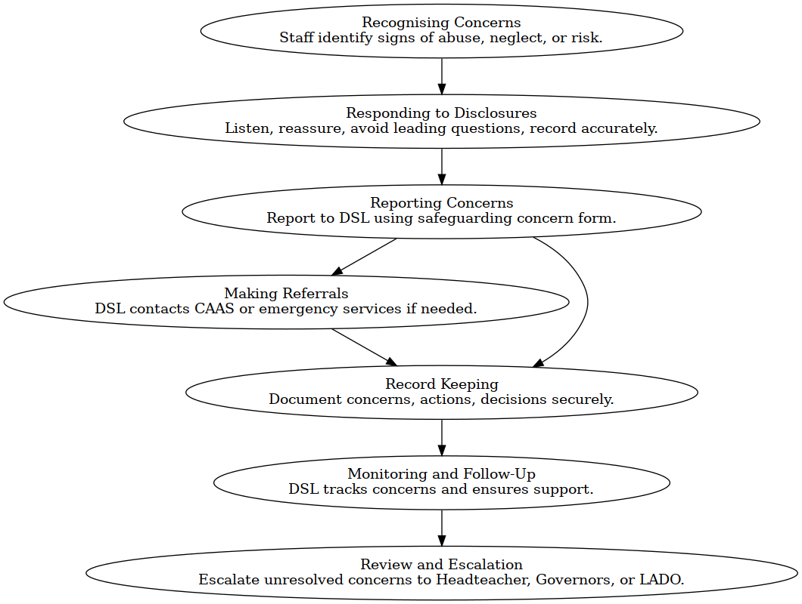

Recognising Concerns
- All staff are trained to identify signs of abuse, neglect, exploitation, and other safeguarding risks, including online harm and peer-on-peer abuse.
- Staff are expected to maintain professional curiosity and act on any concern, no matter how small.

Responding to Disclosures
- If a child discloses abuse, staff must:
  - Listen carefully and reassure the child.
  - Avoid asking leading questions or promising confidentiality.
  - Record the disclosure accurately using the child’s own words.
  - Report the concern immediately to the Designated Safeguarding Lead (DSL) or Deputy DSL.

Reporting Concerns
- All concerns must be reported to the DSL using the school’s safeguarding concern form.
- The DSL will assess the concern and decide on the appropriate course of action, including whether to refer to the Contact, Advice & Assessment Service (CAAS).

Making Referrals
- The DSL will contact CAAS without delay if a child is at risk of significant harm.
- In emergencies, staff should contact the police (999) or CAAS out of hours (01344 351999).
- Parents are usually informed unless doing so would place the child at greater risk.

Record Keeping
- All safeguarding concerns, actions, and outcomes are recorded in a secure, confidential safeguarding file.
- Records include a clear summary, actions taken, decisions made, and the rationale behind them.
- Files are transferred securely when a child moves to a new school.

Monitoring and Follow-Up
- The DSL monitors ongoing concerns and ensures appropriate support is in place.
- Attendance and welfare are closely tracked, especially for vulnerable pupils or those with a history of safeguarding concerns.

Review and Escalation
- If a staff member feels a concern has not been addressed appropriately, they are encouraged to escalate it to the headteacher, chair of governors, or the Local Authority Designated Officer (LADO).

17. Summary procedures for allegations against staff:
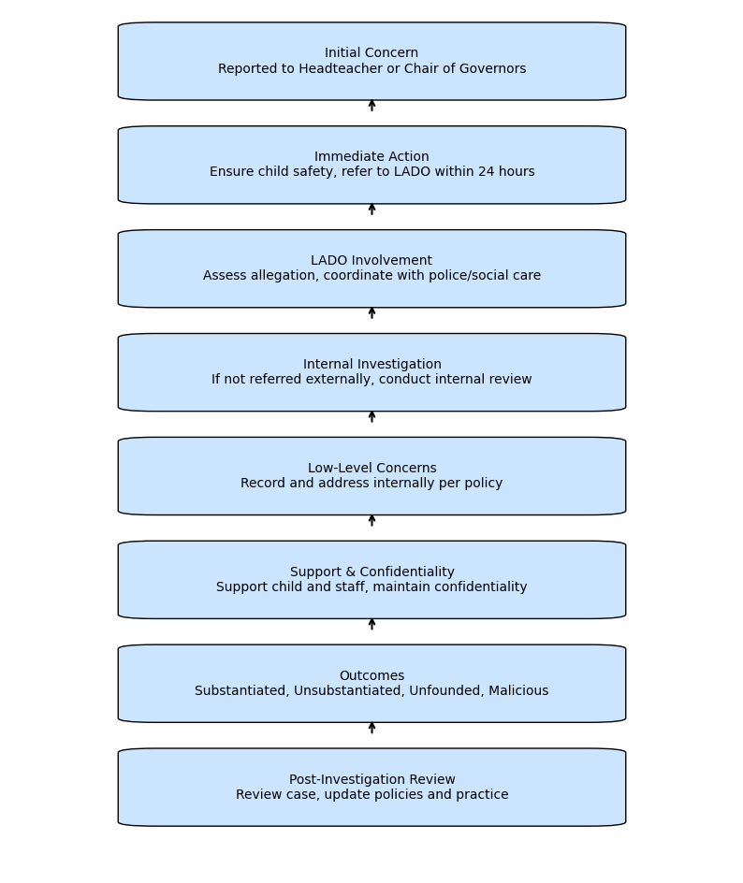

Appendix 1 Indicators of abuse and neglect.
Abuse: a form of maltreatment of a child. Somebody may abuse or neglect a child by inflicting harm or by failing to act to prevent harm. Harm can include ill treatment that is not physical as well as the impact of witnessing ill treatment of others. This can be particularly relevant, for example, in relation to the impact on children of all forms of domestic abuse, including where they see, hear or experience its effects. Children may be abused in a family or in an institutional or community setting by those known to them or, more rarely, by others. Abuse can take place wholly online, or technology may be used to facilitate offline abuse. Children may be abused by an adult or adults or by another child or children.
Physical abuse: a form of abuse which may involve hitting, shaking, throwing, poisoning, burning or scalding, drowning, suffocating or otherwise causing physical harm to a child. Physical harm may also be caused when a parent or carer fabricates the symptoms of, or deliberately induces, illness in a child. 26. Emotional abuse: the persistent emotional maltreatment of a child such as to cause severe and adverse effects on the child’s emotional development. It may involve conveying to a child that they are worthless or unloved, inadequate, or valued only insofar as they meet the needs of another person. It may include not giving the child opportunities to express their views, deliberately silencing them or ‘making fun’ of what they say or how they communicate. It may feature age or developmentally inappropriate expectations being imposed on children. These may include interactions that are beyond a child’s developmental capability as well as overprotection and limitation of exploration and learning or preventing the child from participating in normal social interaction. It may involve seeing or hearing the ill treatment of another. It may involve serious bullying (including cyberbullying), causing children frequently to feel frightened or in danger, or the exploitation or corruption of children. Some level of emotional abuse is involved in all types of maltreatment of a child, although it may occur alone.
Sexual abuse: involves forcing or enticing a child or young person to take part in sexual activities, not necessarily involving violence, whether or not the child is aware of what is happening. The activities may involve physical contact, including assault by penetration (for example rape or oral sex) or non-penetrative acts such as masturbation, kissing, rubbing, and touching outside of clothing. They may also include non-contact activities, such as involving children in looking at, or in the production of, sexual images, watching sexual activities, encouraging children to behave in sexually inappropriate ways, or grooming a child in preparation for abuse. Sexual abuse can take place online, and technology can be used to facilitate offline abuse. Sexual abuse is not solely perpetrated by adult males. Women can also commit acts of sexual abuse, as can other children. The sexual abuse of children by other children is a specific safeguarding issue in education and all staff should be aware of it and of their school or college’s policy and procedures for dealing with it.
Neglect: the persistent failure to meet a child’s basic physical and/or psychological needs, likely to result in serious impairment of the child’s health or development. Neglect may occur during pregnancy, for example, as a result of maternal substance abuse. Once a child is born, neglect may involve a parent or carer failing to: provide adequate food, clothing and shelter (including exclusion from home or abandonment); protect a child from physical and emotional harm or danger; ensure adequate supervision (including the use of inadequate caregivers); or ensure access to appropriate medical care or treatment. It may also include neglect of, or unresponsiveness to, a child’s basic emotional needs.
Educational Neglect: Educational neglect is a form of child neglect that occurs when a parent or carer fails to ensure a child receives an appropriate education. This includes persistent failure to send a child to school regularly, not addressing barriers to attendance, or failing to engage with support offered by the school or local authority. Educational neglect can significantly impact a child’s development, wellbeing, and future opportunities. It may be an indicator of wider safeguarding concerns and should always be taken seriously. Schools have a duty to identify patterns of poor attendance, assess the underlying causes, and take appropriate action, including referrals to Early Help or Children’s Social Care where necessary.

Appendix 2 Further Guidance and Resources:
- Public Sector Enquiry
- Data Protection
- Sharing nudes and semi-nudes - Advice for education settings working with children
- Harmful online challenges
- Safeguarding & remote education
- Working together to Improve School Attendance (Aug 2024)
- Domestic Abuse - How to get help
- Use of reasonable force in schools
- What to do if you’re worried a child is being abused
- Criminal records checks for overseas applicants
- Check for teacher prohibition
- Concerned about an Adult Working with Children
- information Sharing Advice
- Whistleblowing: guidance and code of practice for employers
- Guidance for parents/carers on using after school clubs
- Safeguarding in Sport
- When to call the police
- Education inspection framework (EIF)
- Searching, screening and confiscation
- Reducing the need for restraint
- Alternative Provision
- Arranging education for pupils with health needs

